FINMA Circular 2023-1 Compliance for Log360
Tagline: Fulfill FINMA's requirements with centralized log monitoring and analytics from Log360.

Overview
The FINMA Circular 2023/1 — Operational Risks & Resilience Compliance extension for Log360 helps Swiss financial institutions meet FINMA's stringent requirements for IT risk management, operational resilience, and incident reporting.
Log360 collects and correlates logs from banking applications, cloud environments, network devices, and identity systems, providing continuous visibility into security events. Security and compliance teams can monitor critical control points, detect operational anomalies, and generate detailed audit evidence to satisfy FINMA's supervisory expectations and internal governance obligations.

Key Features
- Generate comprehensive audit reports covering IT operational risk controls, user access monitoring, and system availability events aligned to FINMA Circular 2023/1.
- Track privileged user activity, administrative changes, and access control modifications across financial IT systems in real time.
- Centralize log data from across your infrastructure to maintain real-time visibility into user activity and access patterns, supporting proactive threat identification and FINMA compliance posture.
- Export audit evidence in PDF and CSV formats to support FINMA submissions, internal risk committees, and external auditor reviews.
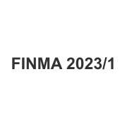
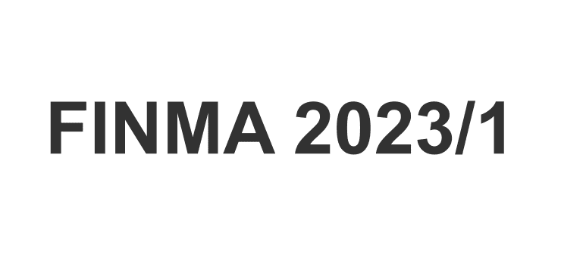

Screenshots
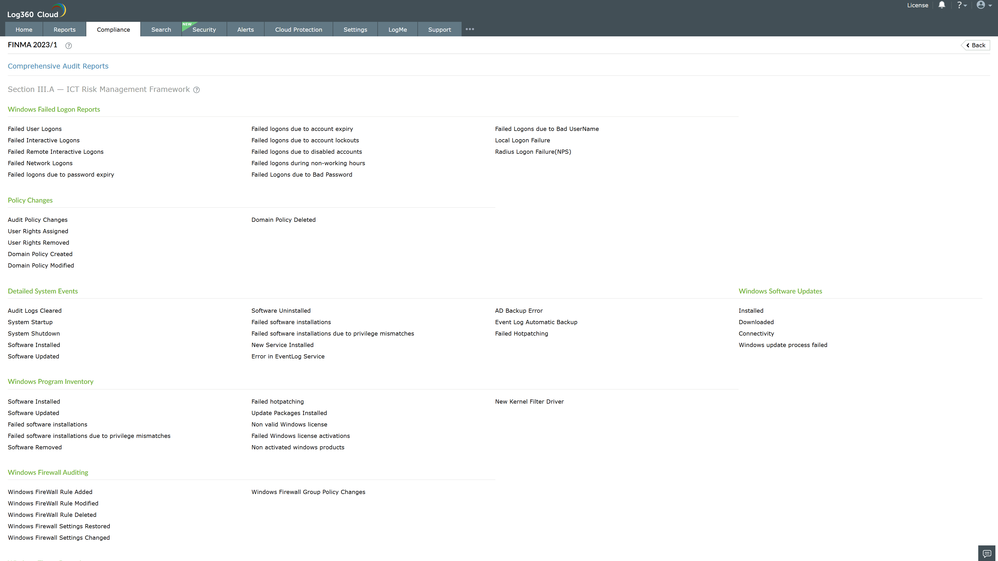
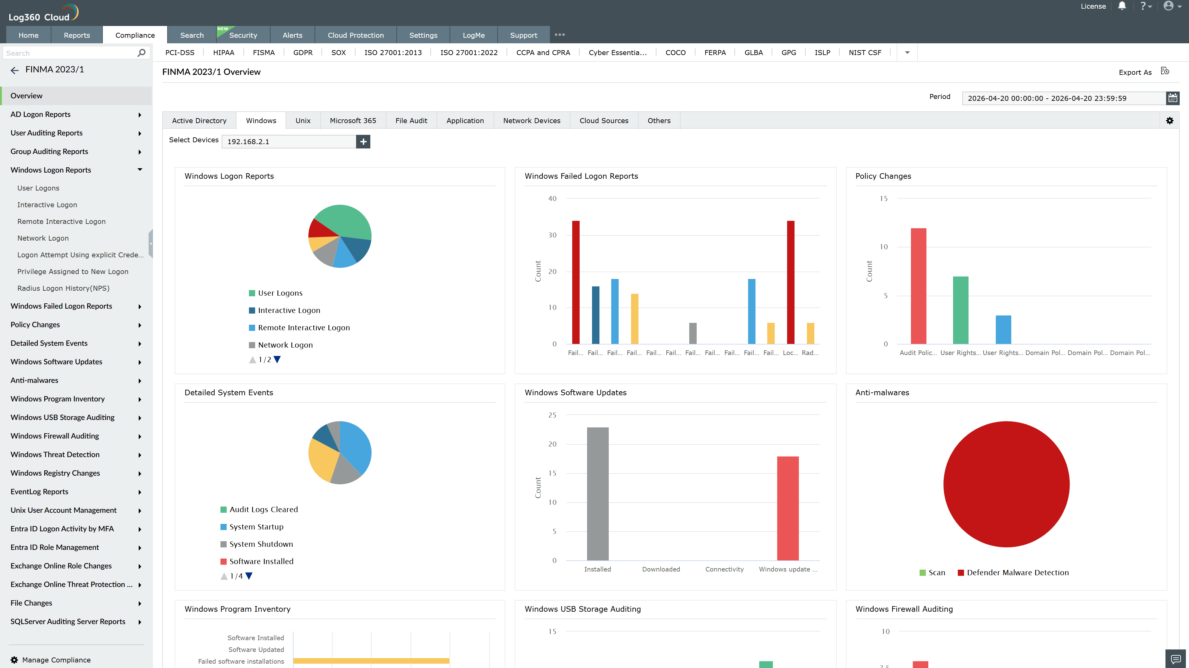
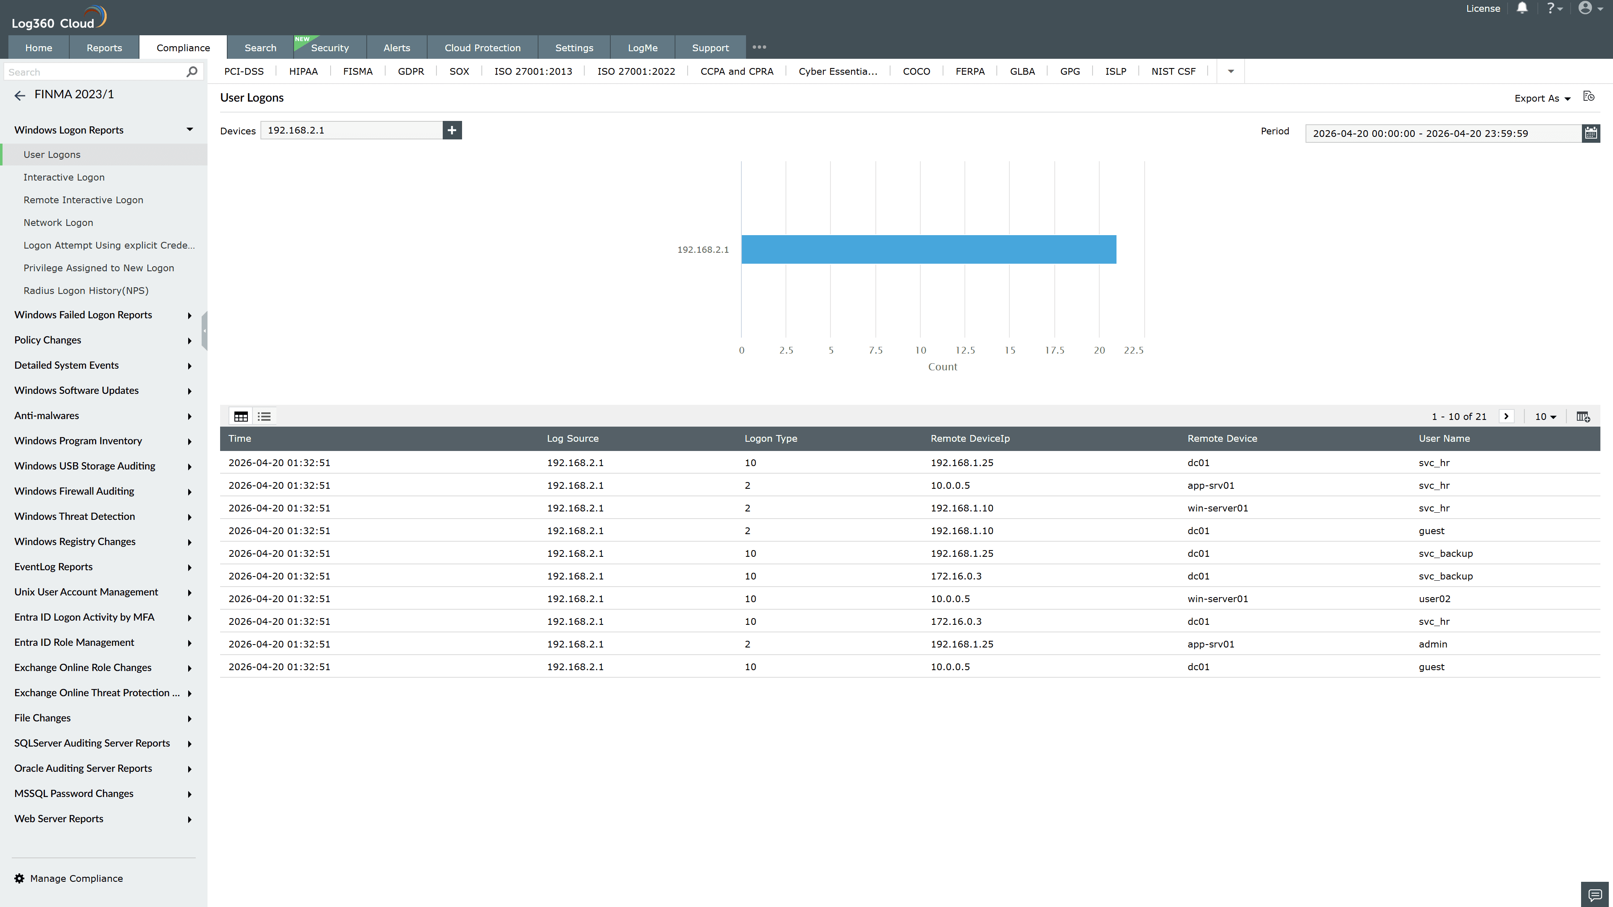
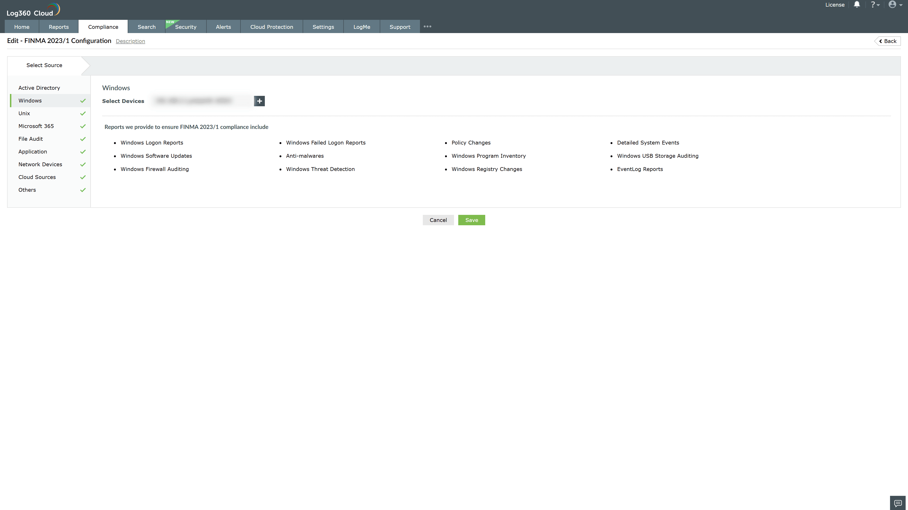

Valid Submission : Yes
Supported Editions : Free, Basic, Standard, Professional, MSSP
Help Document : https://www.manageengine.com/log-management/help/integrations/compliance-extensions.html
Help Video : Not provided
Tags : Log360, Compliance, Privacy monitoring, Data privacy, Regulatory compliance
Supported DCs : US, IN, JP, CA, AU, UK and EU
Privacy Policy:
Terms of Service:
Release Notes:
Predefined reports for the FINMA Circular 2023/1 Compliance

